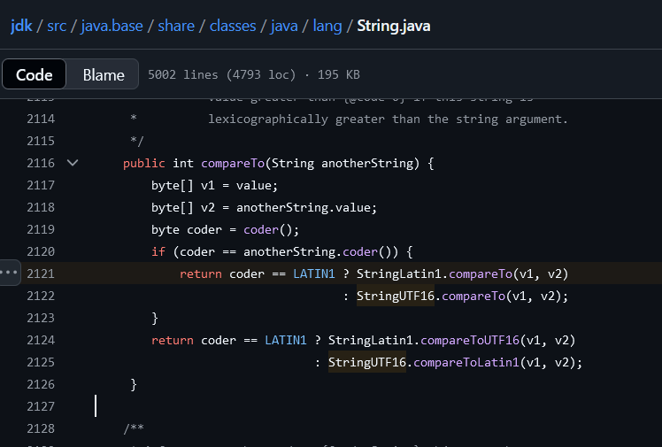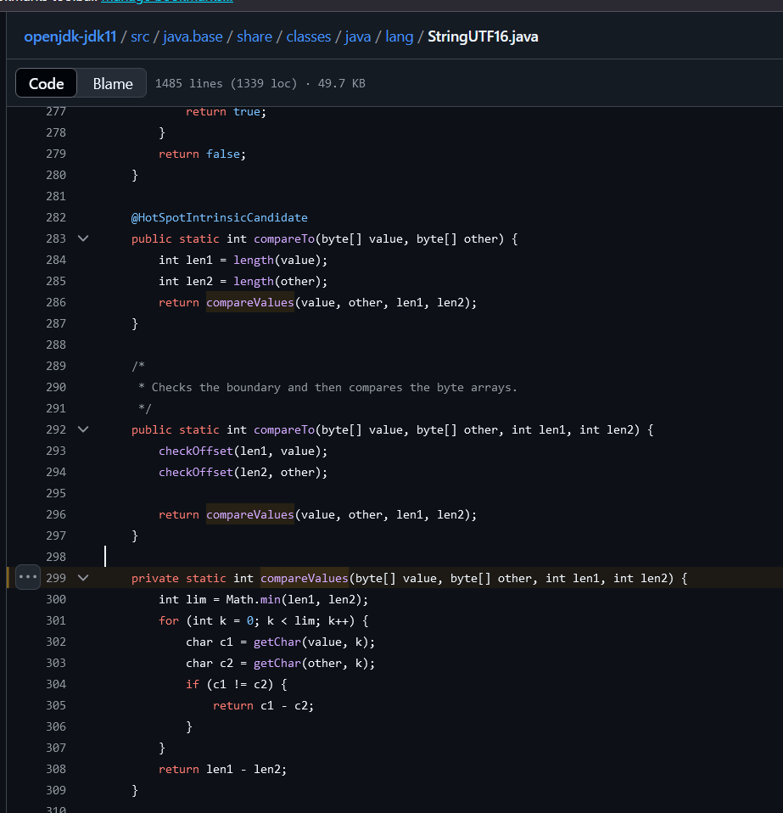

String str1 = "apples";

String str2 = "banana";

int result = str1.compareTo(str2);

System.out.println(result);

// Will print a negative number because "a" < "b"

String str1 = "apple";  
String str2 = "applepie";  
int result = str1.compareTo(str2);  
System.out.println(result);

// Will print a negative number because "apple" is shorter than "applepie"

String str1 = "Applepie";

String str2 = "applepie";

int result = str1.compareTo(str2);

System.out.println(result);

// Will print a negative number because 'A' < 'a'

'1' < 'A' < 'a'

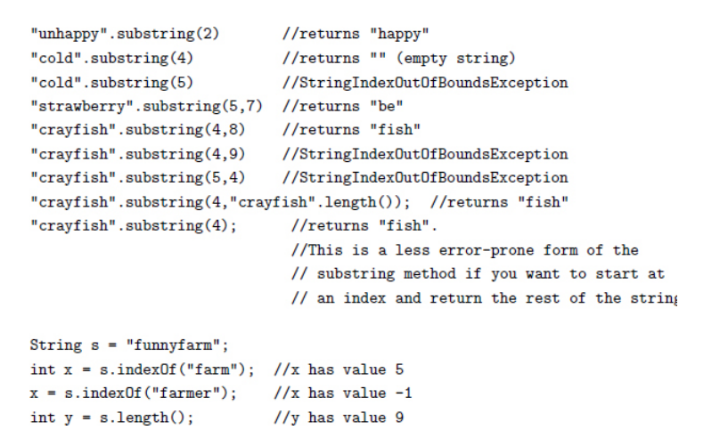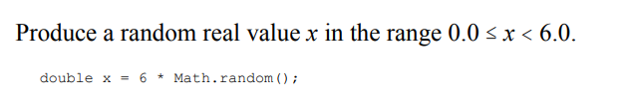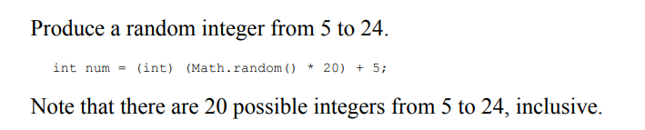

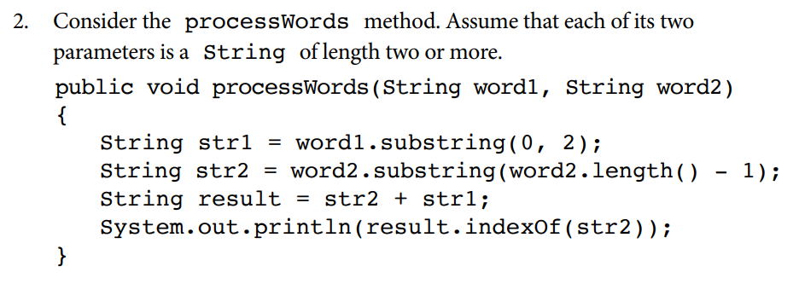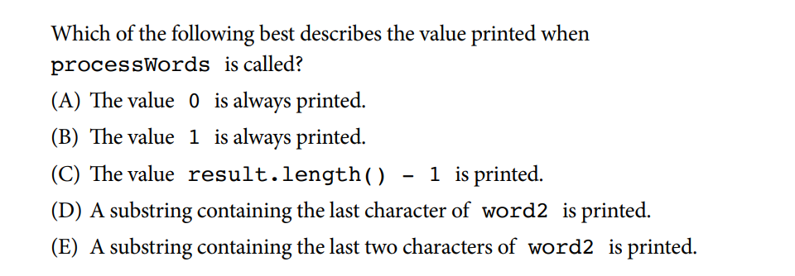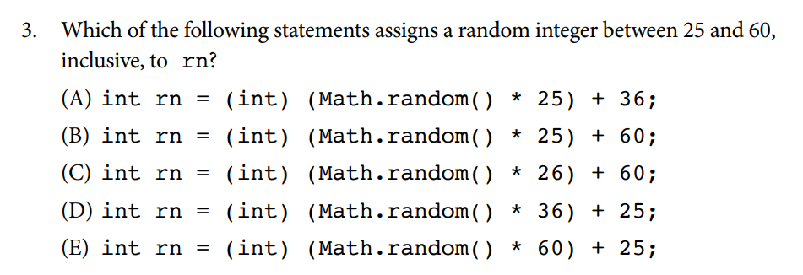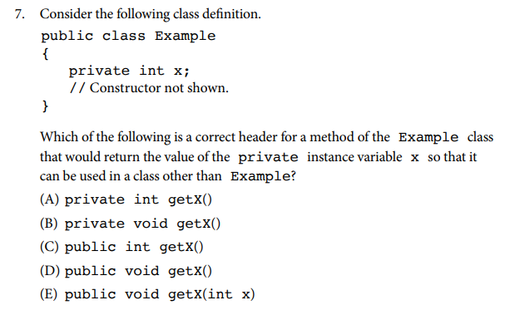

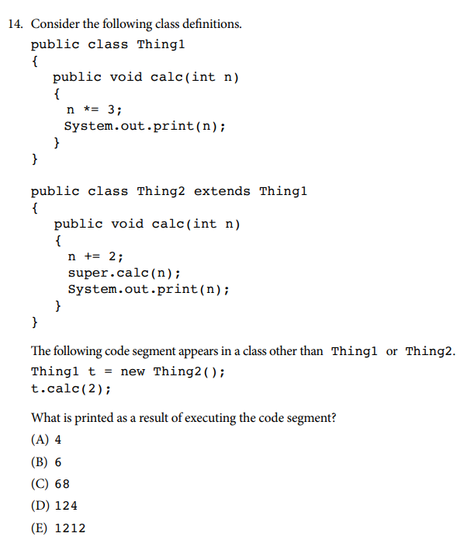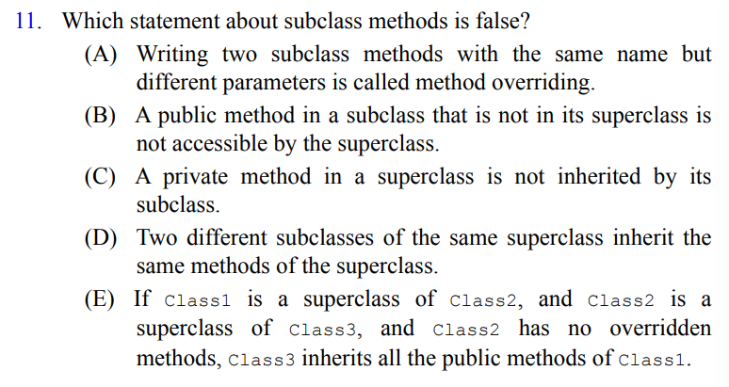

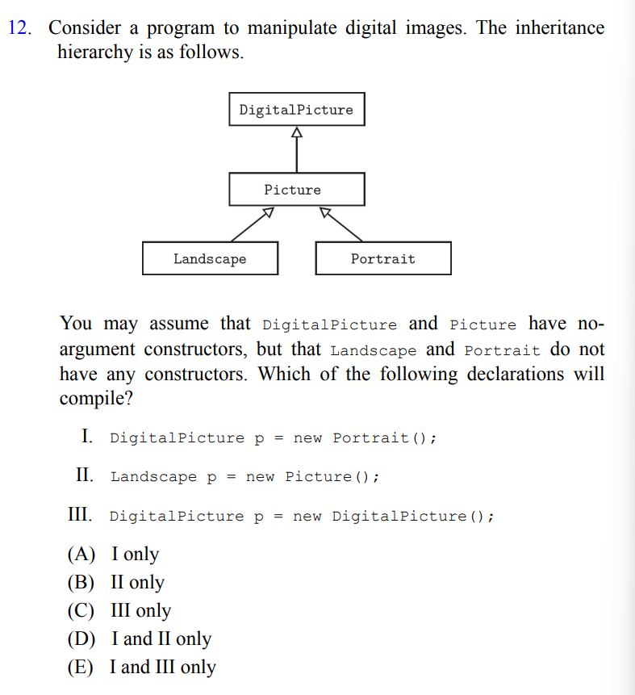

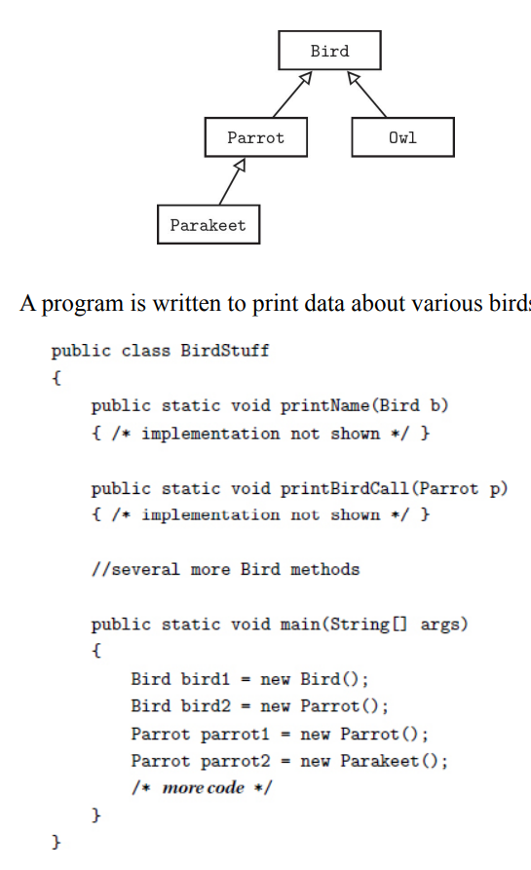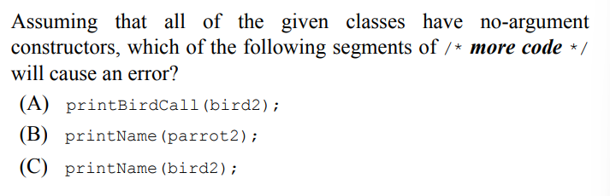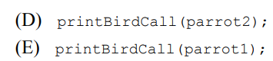

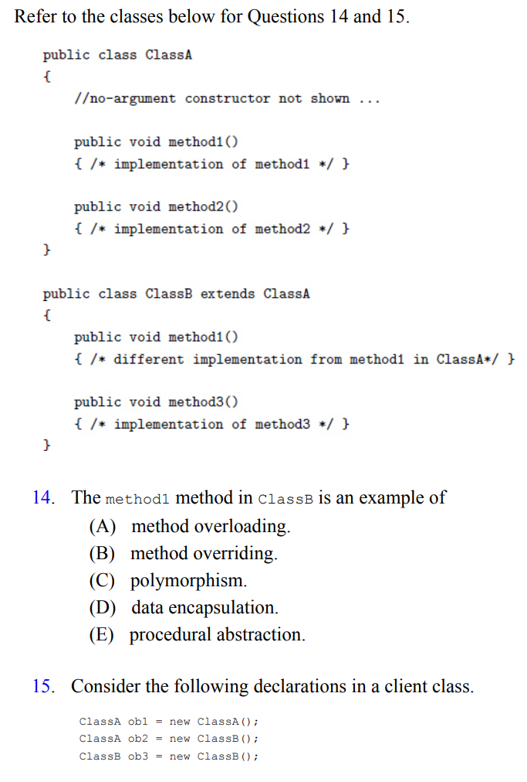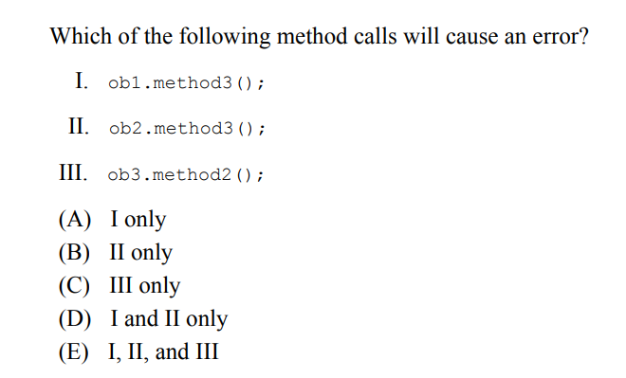

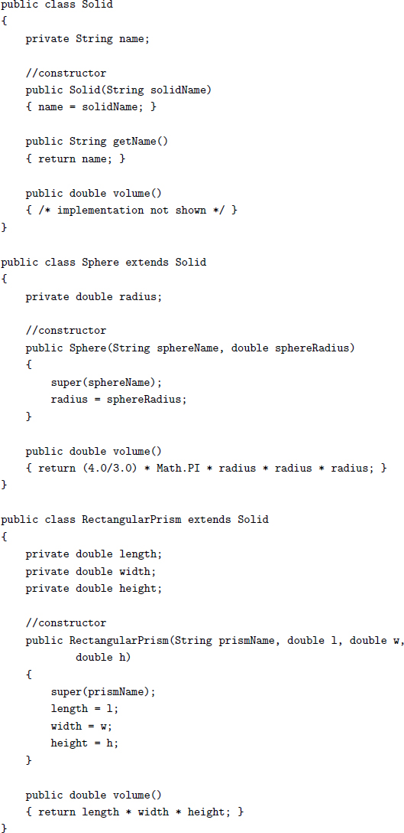

16. A program that tests these classes has the following declarations and

assignments:

Solid s1, s2, s3, s4;

s1 = new Solid("blob");

s2 = new Sphere("sphere", 3.8);

s3 = new RectangularPrism("box", 2, 4, 6.5);

s4 = null;

How many of the above lines of code are incorrect?

(A) 0

(B) 1

(C) 2

(D) 3

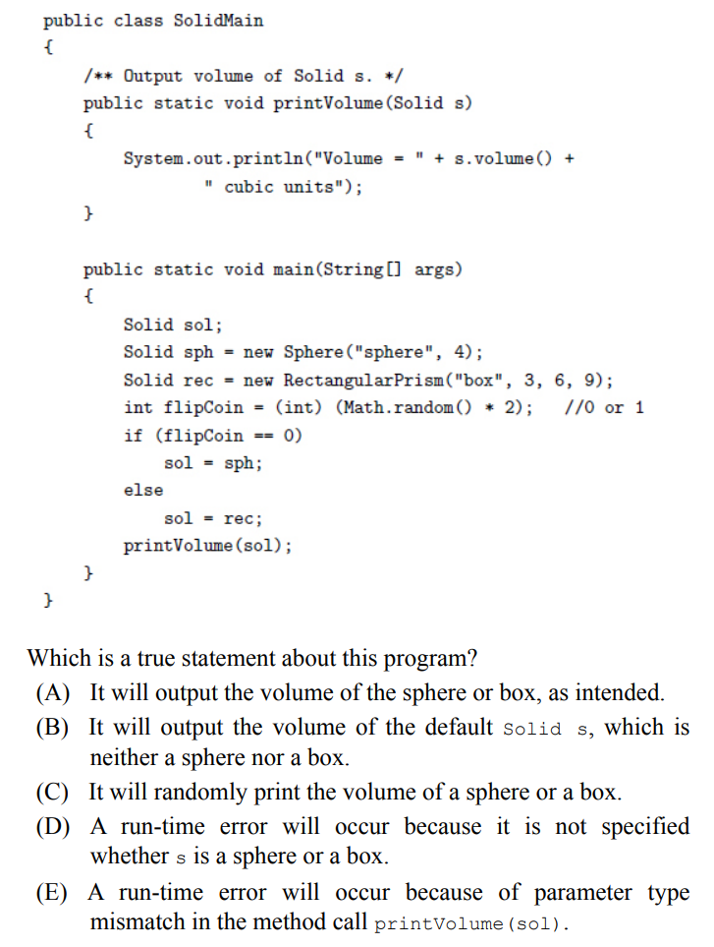(E) 4

